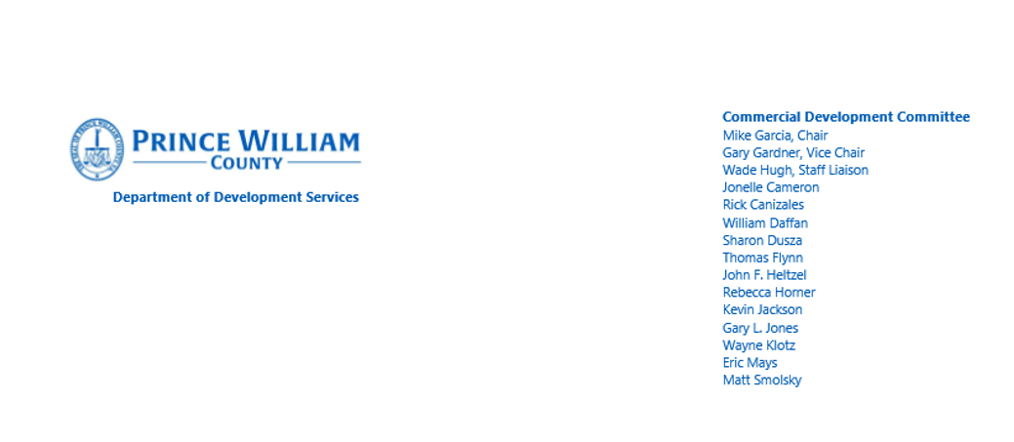
Agenda
2:30 p.m., Wednesday, January 20, 2021

- Introductions
  - Introduce Parag Agrawal – New Planning Director

- Highlight the Board’s Commendation for the CDC’s 20 years of volunteer service
  - CDC book

- Elect Chair and Vice Chair for 2021

- FY2022 Budget
  - Discuss proposed changes to the land, building and fire fee schedules

- CDC’s recommendation to increase the commercial tax base (reference two attachments)
  - BOCS meeting discussions – close the loop on the CDC recommendations for moving the needle on 35% commercial tax base

- Review County Small Business Project Management Program Successes
  - Share two years of data

- Establish goals for 2021
  - Still need to work on the Bonded improvements (review Loudoun County’s policies)

- Review Performance Measures
  - This is the typical plan review, permit and inspection data that I provide each quarter

- Other Business

- Meeting adjourned

